How to Analyze Games – a Parent’s Guide
The nice thing about modern tools is that you don’t need to be an expert on chess in order to help your child grow and learn about the game. If you know the very basics, the computer will do all the hard stuff for you.

This is a guide on how you can help your child review their own games and learn from their mistakes.

The first requirement is that your child is taking notation of their games. Without that, there’s no record of the game and nothing to review. In more serious settings, such as tournaments above a certain school grade or rating, notation will be required. It’s also one of the most productive ways to improve at the game. Hopefully you have a record provided of one of your child’s games from this chess camp. We’ll go over what this does, how to use it, and how to create it from scratch.

You likely have a link sent to you of one of your child’s games. We’ll start from there, and then go back and show you how to create this from scratch.

I recommend starting by creating an account on https://lichess.org. This is a completely free website with no ads run by a non-profit organization, and what we’ll be covering in this guide. https://chess.com is the more popular, for-profit alternative and is also fine.

Table of Contents
1. How to use game analysis 2
A. Computer Analysis Graph 3
Piece value and game lead values. 3
Board Orientation – View from Black or White. 4
B. Move Table 5
C. Mistakes 6
2. Importing a game from notation 7
A. Moving the pieces 7
B. Typing the game 9

1. How to use game analysis

When you visit the link, the game will look something like the following:
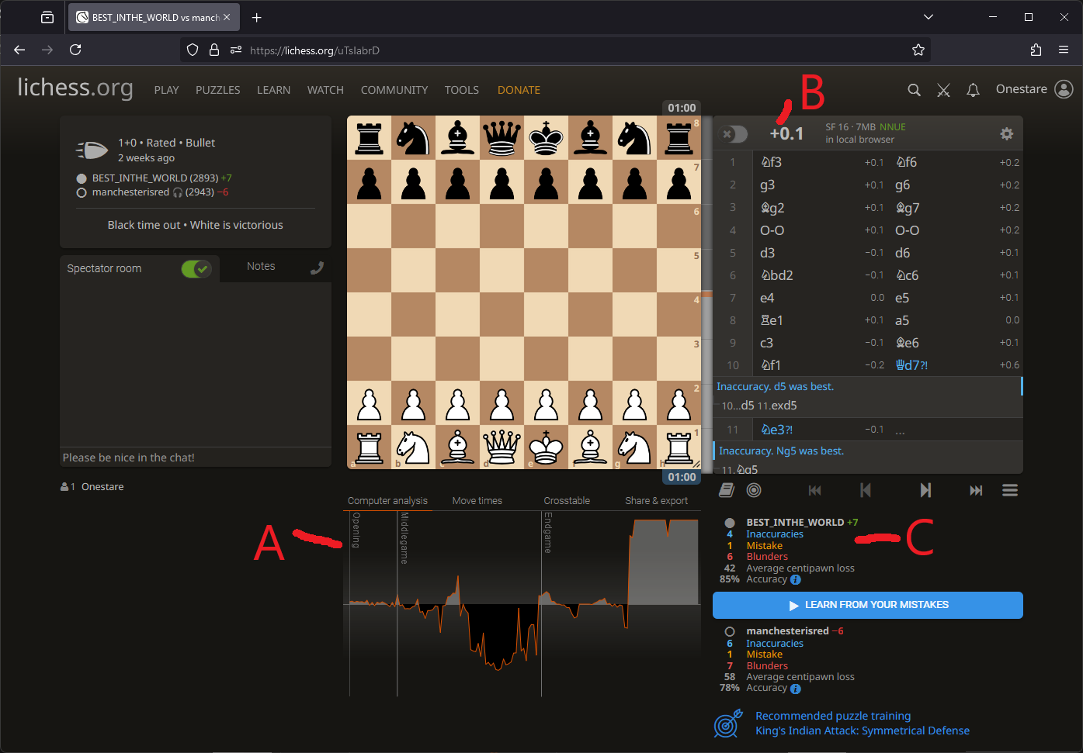
In the next few pages, we’ll describe each of these.
A. Computer Analysis Graph
B. Move Table – includes flipping the board in case you’re the black pieces!
C. Mistakes

A. Computer Analysis Graph
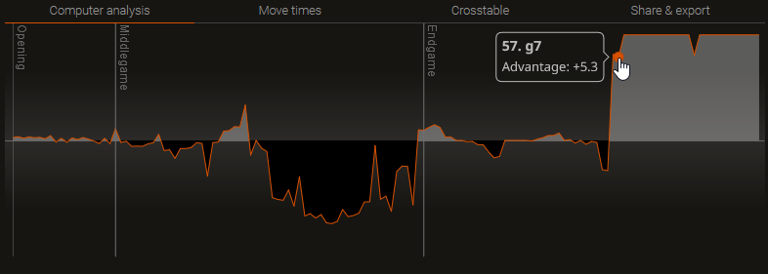
A graph of who is leading throughout the game if both players play “perfectly” (to the best of the computer’s ability). The left is the first move of the game and towards the right is later in the game. If you mouse over various parts of the graph it will tell you either a number or a # and then an integer. The # (pound or hashtag) means checkmate. #3 would mean that given perfect play, a checkmate is possible in 3 moves. A number without the hash measures the lead in game lead value (evaluation). See the section on “Piece value and game lead values” to understand what these numbers measure. A positive value means white is winning, negative is black winning, and 0.0 is an even game. White, because they go first, always starts with a small advantage. That going first advantage is considered to be worth 1/5th of a pawn (0.2).

Piece value and game lead values.

Pieces are assigned values that roughly describe what they’re worth relative to each other. The queen, being the most valuable piece that can be lost, is worth 9 points. Each pawn is 1 point. The rooks are 5 points each. The bishops and knights are worth 3 points each. In a real game, the bishops and knights tend to have slightly different values based on the state of the board. Bishops tend to be better when there are fewer pawns on the board, and knights are better when there are more pawns on the board.

The measure of who’s leading is not exact, and takes in the position and possible moves of the pieces, not just the pieces themselves (which are called “material”). A player who has the opportunity to take the opponent’s queen for free in the next two moves might be at a temporary material disadvantage (say -3), but the graph would show them having the game advantage (say +6) given their opportunity to take the opponent’s queen soon.

Board Orientation – View from Black or White.
There are two ways to flip the board between Black and White. Typically, white is shown by default. One is to change the URL to have /black or /white at the end.
https://lichess.org/uTsIabrD is the same as https://lichess.org/uTsIabrD/white and the other is https://lichess.org/uTsIabrD/black.
The other way is to do it from the menu and “flip board” as shown below.
I’ve just found that you can do both, but that’s really, really confusing and I wouldn’t recommend it. If you’re the white pieces, make sure the a1 square is on the bottom left side. If you’re the black pieces, make sure the h8 square is on the bottom left side.
Just as general knowledge for live (called “Over the Board”) games, the bottom left square for either player should always be a dark square. Usually if there’s a crease in the board, that crease will be between the two players, and not vertical. If the board has numbers and letters, verify that the black pieces are on the 8th rank and the white pieces are on the 1st rank. Occasionally new players will swap these and really confuse their notation.
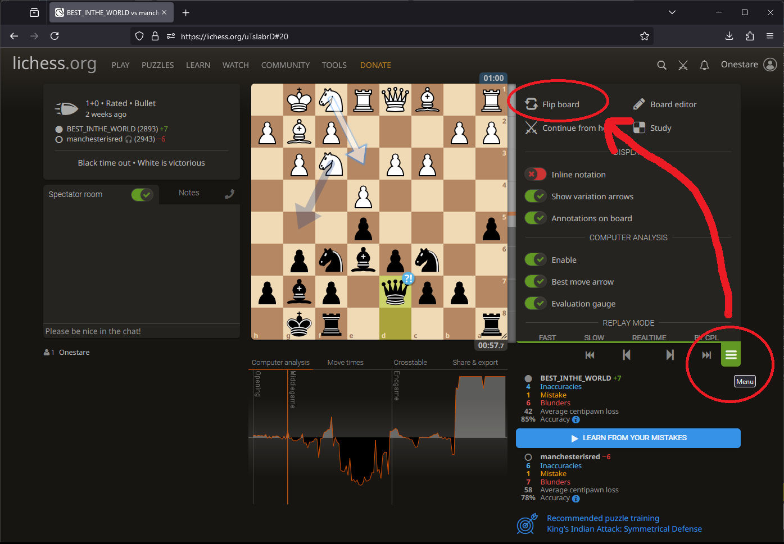
Most of the board and screen is actually neutral. Technically you can play either color by looking at the board from any angle, but of course it’s easier to play with the board in the “correct” orientation. The “Learn from your mistakes” button also starts with whichever player the board is facing.

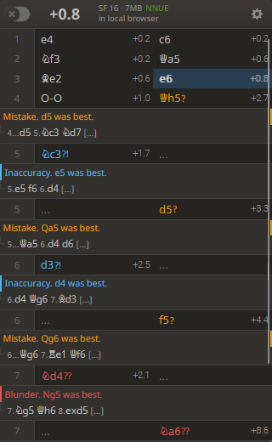
B. Move Table
The move table is a list that shows all the moves played during the game. It should look very similar to the players’ notation. If you click one of the moves, the board will display the game at that point in time. Additionally, the number, both at the top and next to the move, is the game evaluation as described above.
If the players’ notation is wrong, typically an illegal move, this table will stop at the last legal move. The letters for the pieces will be translated to symbols. Remember, K is king and N is knight. If you’re signed into an account you can change this setting at the link below.
https://lichess.org/account/preferences/display#pgnPieceNotation
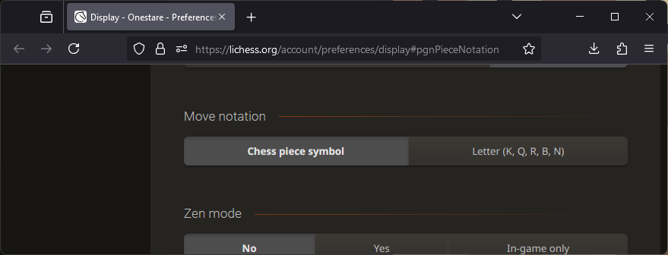

C. Mistakes
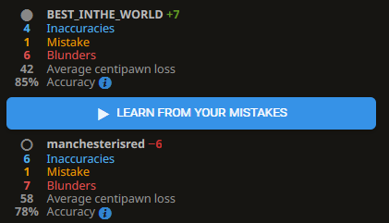
This shows a list of all the mistakes made by each player, categorized by how bad the mistakes are. Inaccuracy means there was something slightly better, and, well, players of all skill levels make blunders. The critical part of this is the “Learn from your mistakes” button, which is an amazing teaching tool.
This is all you need if you’re provided a lichess link to review the game. Next we’ll show you how to generate this link from your child’s notation. Then we’ll have a couple bonus sections to help you watch live games and do further analysis. Much like watching pro basketball, none of this will require knowing strategy or being good at the game. Though it will absolutely help if you do decide to learn!

2. Importing a game from notation
There are two ways to import a game from notation, either moving the pieces or typing it out. We’ll cover both. If you’re more confident that the notation is correct, I find typing it out to be faster. If you’re more wary, making the moves on the board can be less frustrating and help you correct errors.

A. Moving the pieces
On lichess.org, while signed in, select Tools > Analysis Board.
Make all the moves as best you can. Attempt to figure out the ones that might be wrong. You can right click a move and “delete from here” if needed. If you can only get half the game before you lose track of what they did, that can be okay for now and a lesson for next time.
When complete, copy the PGN text at the bottom (Ctrl + A to select all, Ctrl + C to copy). I recommend opening notepad or similar and pasting (Ctrl + V) into that to save the data temporarily.
(Continued...)
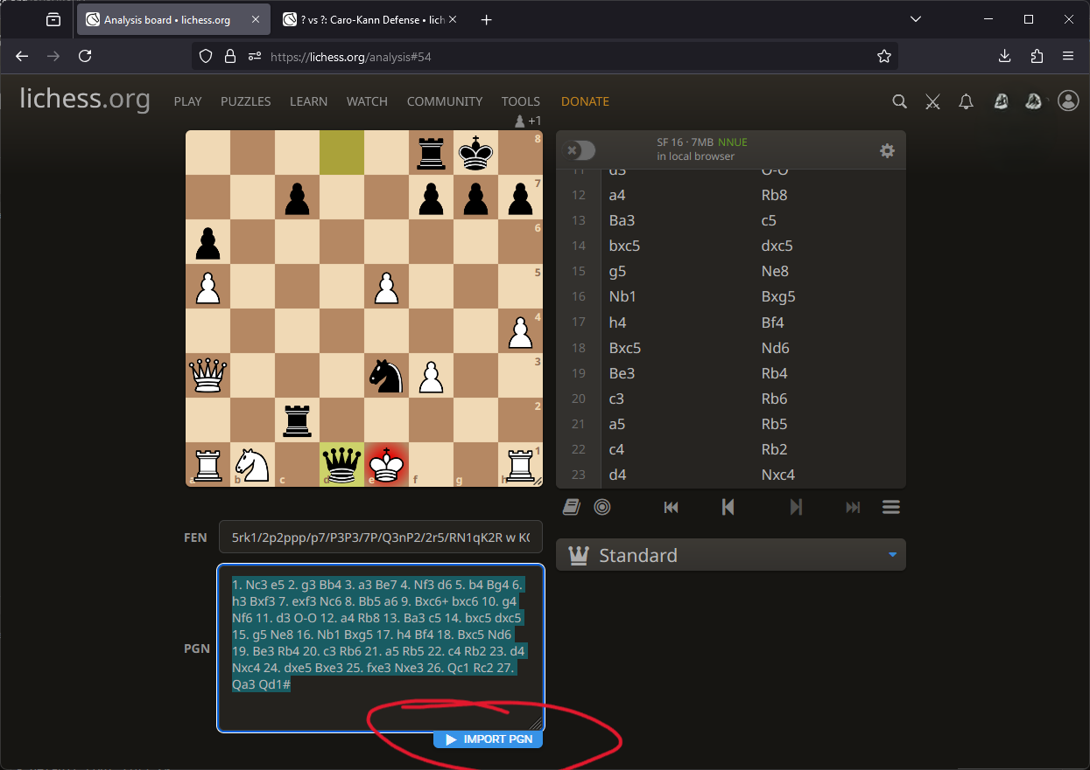
Once you have the text copied, select Tools > Import game. (You can also try the circled “Import PGN” button, but it didn’t work for me.) Paste the PGN text where directed. For now, turn off the “Request a computer analysis” button, and select “Import Game”.
On the move table to the right, scroll to the bottom and make sure the last move there is the last one you intended to enter. If it didn’t get all of it, there was likely an illegal move where it left off. If you’d like to try again, I’d recommend deleting the game at the top left. As long as you still have your text saved somewhere (such as notepad), you won’t lose your work.
Once that’s verified, hit “Request a Computer Analysis”. You can then analyze the game as described at the start of this document.
If you want to really have a detailed record, you can select the “Share & export” tab, and copy out the text with the automatically added annotations. You can edit these annotations in something like notepad, delete the current game, and then import them again. This is how you can add things like player names, date, event name, etc.
You now have a fresh game to analyze! You can continue with 1. How to use game analysis.

B. Typing the game
If you trust the annotation a bit more (doesn’t have to be 100%), I find it faster to type. I recommend starting by using a fancy text editor that has line numbers. Some that I recommend are Sublime Text, Notepad++, or Visual Studio Code.
Enter all the text just as the players have. You don’t need to include line numbers. Your fancy text editor will show them to you for reference, and they’re not needed other than that. Make sure the first move is on line 1 so that if there’s a mistake, you can reference the line/move numbers. Note that in chess, one “move” is both players. The first move of the game is white and then black. The second move of the game is white and then black, and so on. You might save this text file for your reference.
When complete, copy the text (Ctrl + A to select all, Ctrl + C to copy). On lichess.org select Tools > Import game (this requires you to have a login). Where it says “Paste the PGN text here”, paste (Ctrl + V) the text you’ve copied. Make sure the “Request a computer analysis” is off for now and press “Import Game”.
(Continued...)
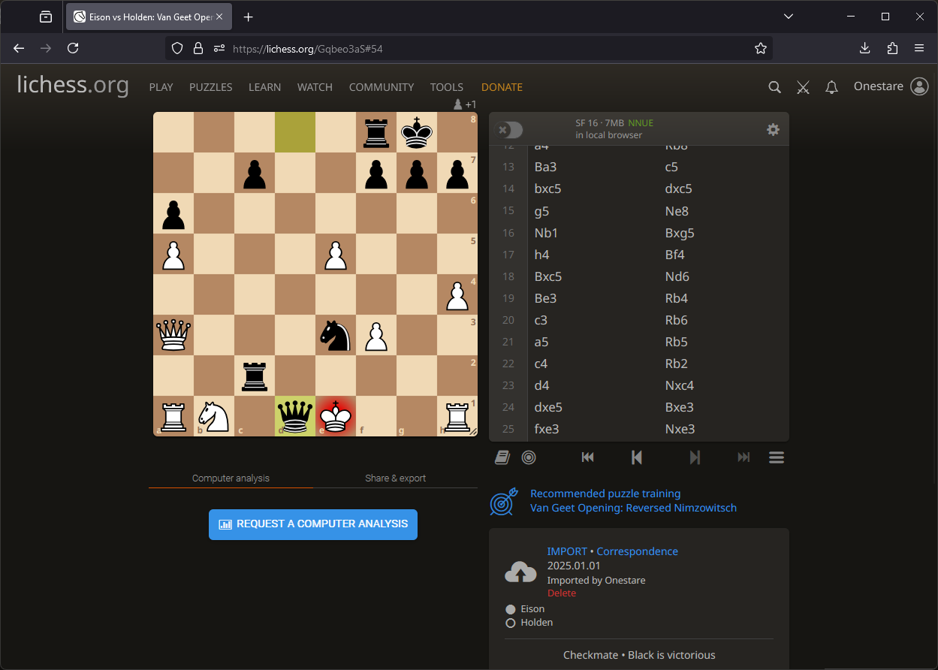
On the move table to the right, scroll to the bottom and make sure the last move there is the last one you intended to enter. If it didn’t get all of it, there was likely an illegal move where it left off. If you’d like to try again, I’d recommend deleting the game at the top left. As long as you still have your text saved somewhere (such as notepad), you won’t lose your work.
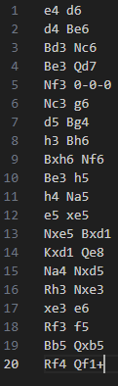
It should look something like the image to the right.
Once that’s verified, hit “Request a Computer Analysis”. You can then analyze the game as described at the start of this document.
If you want to really have a detailed record, you can select the “Share & export” tab, and copy out the text with the automatically added annotations. You can edit these annotations in something like notepad, delete the current game, and then import them again. This is how you can add things like player names, date, event name, etc.
You now have a fresh game to analyze! You can continue with 1. How to use game analysis.

